***Ist Author et al., International Research Journal of Computer Science***

Sentiment Analysis of Customer Satisfaction using Deep

Learning

Shreyas Rajesh Labhsetwar

*Department of Computer Engineering,*

*Fr. C. Rodrigues Institute of Technology,*

*Navi Mumbai 400703, India*

*Email :* shreyas.labh@gmail.com

***Abstract****—****The rapid advancement of web technology has led to an exponential increase in the volume of data present***

***online for internet users. Travellers book their hotels only after extensive scrutinisation of hotel reviews on online***

***websites. Hence, it is an absolute necessity for hotel’s management board to gain insights from customer reviews and***

***feedbacks to improve upon their services for a better customer satisfaction index.***

***This research explores the use of Artificial Neural Networks (ANN) powered by Google's Word2Vec skip-gram***

***algorithm for customer sentiment analysis and review classification. The proposed model achieves a high test***

***accuracy of 0.9248, with an average F1-Score of 0.925. Unsupervised sentiment clustering effectively classifies the***

***reviews into four distinct categories and enables the Hotel Management to work out the major problems experienced***

***by the customers.***

***Keywords— Deep Learning, Artificial Neural Networks, Sentiment Analysis, Customer Satisfaction.***

I. **INTRODUCTION**

With a rapid increase in the volume of data present online, computationally intelligent methods are proving to be

extremely important to analyse the data in many industries. For example, in telecommunication industry, data is mined

for extracting patterns which would help predict and pre-empt potential customer churn, and improve customer retention

and marketing [1].The advancement of Internet has changed the way millions of people express their views and opinions,

which is now mainly through online forums, booking websites, blog posts, and social media. The online communities are

a source of interactive media enabling consumers to inform and influence others. People mostly make their decisions

based upon online content, making it extremely essential for companies to gain insights to improve upon their user

experience and fetch good reviews [2]. The huge amount of data that warrants analysis is actually present in written form

as reviews and feedback instead of mathematical data. The written text is subject to interpretation, and converting and

representing the data in an absolute mathematical syntax (such as a binary system) is cumbersome. However,

computationally intelligent methods allow for such fuzziness, and successfully extract patterns from such data [3].

Sentiment analysis consists of various computational areas such as natural language processing, data mining and text

mining, and is rapidly becoming crucial to organisations as they strive to integrate computationally intelligent algorithms

into their operations, and attempt to improve upon their products and services [4].

Established organizations as well as individuals can make use of sentiment analysis and opinion mining. When an

individual wishes to buy a product or decides whether to use a service or not, he/she can go through a large number of

user reviews, but reading manually and analyzing all of them would be a lengthy and time consuming process. Also,

when an organization seeks to understand the public opinion about their products, it needs to consider an overwhelmingly

large data of available customer reviews [5]. With sentiment analysis algorithms, large amounts of data can be analysed

automatically to gain insights of opinions and patterns. Also, the bulk of data can be classified into a definite number of

classes. Thereafter, the classes critical to an organisation’s growth can be scrutinised with a higher priority to improve

upon the shortcomings. The effectiveness of such measures can be clearly identified with shrinking number of reviews in

critical classes.

II. **RELATED WORKS**

B. Pang and L. Lee used the most popular approach for sentiment analysis called the bag of words approach consisting

of two modes of summarization; single-document opinion-oriented summarization and multi-document opinion-oriented

summarization. They also delved into the application of unsupervised machine learning approaches and classification,

thereby evaluating the economic impact of reviews and implications of manipulation [6].

V. Rentoumi, S. Petrakis, M. Klenner, G. A. Vouros, and V. Karkaletsis proposed a hybrid model comprising of machine

learning system and rules-based system in which the issue of erroneous evaluations due to lack of decision making

capability pertaining to polarity orientation of sentences was tackled . The approach is evaluated on the rotten tomatoes

movie reviews dataset and compared with other state of the art approaches [7].

In Research [8], social media analytics is performed on twitter data using support vector machine algorithm to classify

tweets into positive and negative categories, achieving a classification accuracy of 87%.

Stanimira Yordanova and Dorina Kabakchieva presented an approach for prediction of customer opinion using decision

tree algorithm for binary classification of hotel reviews as positive or negative. They demonstrated that most accurate

classification is achieved after removal of rear words and applying the model generated from the balanced training set

[9].

***© 2014, IRJCS All Rights Reserved Page | 1***

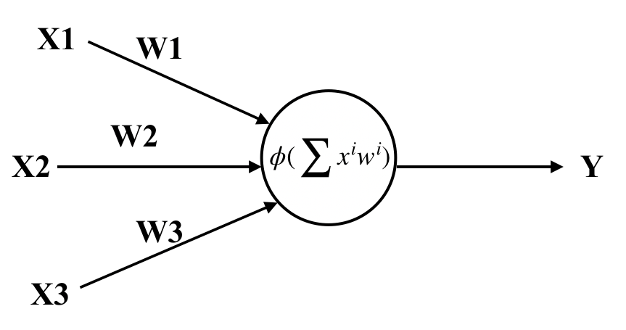

***Ist Author et al., International Research Journal of Computer Science***

III. **DATA SET**

The dataset used in this research [10] was scraped from Booking.com, and is publicly available. It consists of 515,000

customer reviews and scoring of 1493 luxury hotels across Europe, with their geographical locations. Table 1 highlights

all the 17 attributes contained in the dataset.

**FEATURE**

HotelAddress

ReviewDate

AverageScore

HotelName

ReviewerNationality

NegativeReview

Review_TotalNegativeWord_Counts

PositiveReview

Review_TotalPositiveWord_Counts

ReviewerScore

Total_Number_of_Reviews_Reviewer_Has_Given

TotalNumberOfReviews

Tags

DaysSinceReview

AdditionalNumberofScoring

HLatitude

HLongitude

**DESCRIPTION**

Address of the hotel

Date of posting the review.

Average score of the hotel, calculated based on the latest

comment in the last year.

Name of the hotel

Nationality of the reviewer

Negative Review the reviewer gave to the hotel

Total count of words in NegativeReview

Positive Review the reviewer gave to hotel

Total count of words in PositiveReview

Score given by the reviewer to the hotel

Number of reviews the reviewer has given in the past

Total number of valid reviews a hotel has.

Tags given by reviewer to the hotel

Duration between the review and scrape date

Numbering of scorings (not reviews)

Latitude of the hotel

Longitude of the hotel

TABLE 1

IV. **METHODOLOGY**

*A. Deep Learning*

Deep learning is a type of machine learning methodology that empowers computers to imitate the way humans

perceive items and gain knowledge. Deep learning is an intricate element of data science, which includes statistics and

predictive modelling.It is being applied in various domains including agriculture, health-care, cyber security, robotics,

computer vision, and natural language processing [11].

Deep learning involves building up a neural network capable of extracting valuable insights from any form of data. A

neural network is made up of multiple neurons interconnected with each other, such that each connection of the network

is associated with a weight, which gets multiplied to the input value, thereby generating a weighted output.

Fig. 1 An Artificial Neuron

***© 2014, IRJCS All Rights Reserved Page | 2***

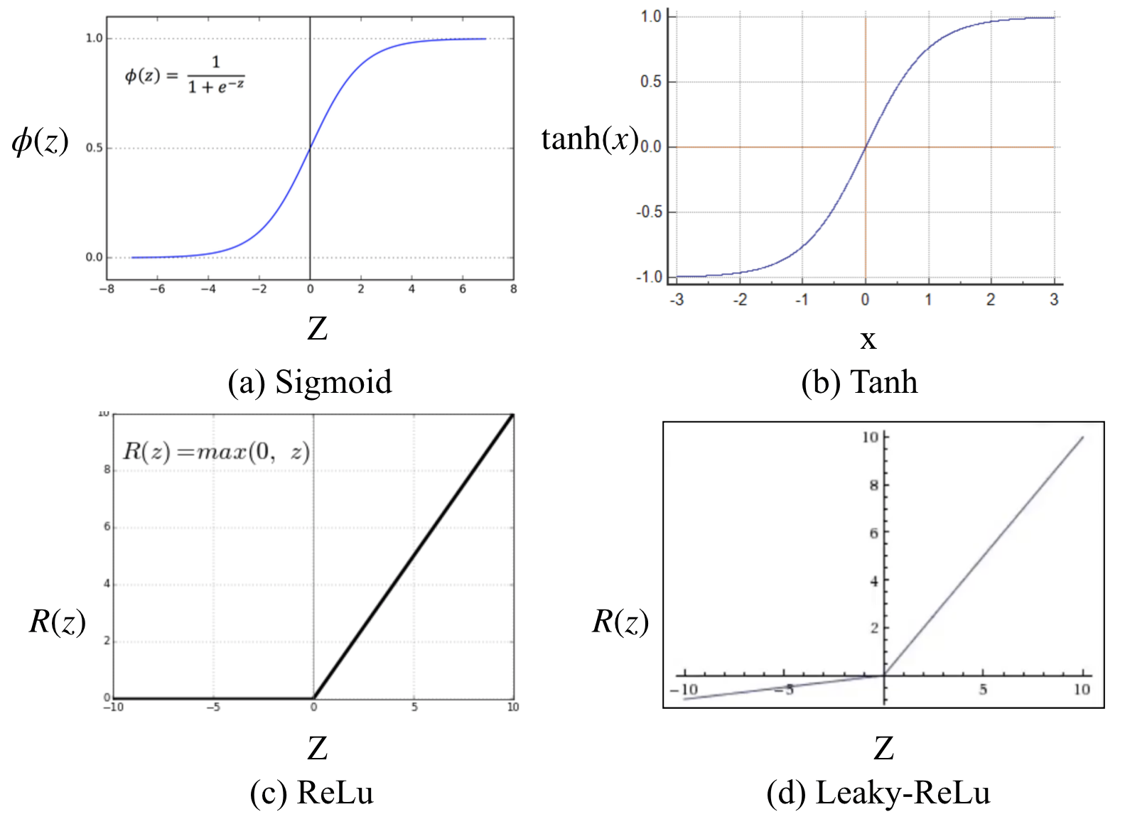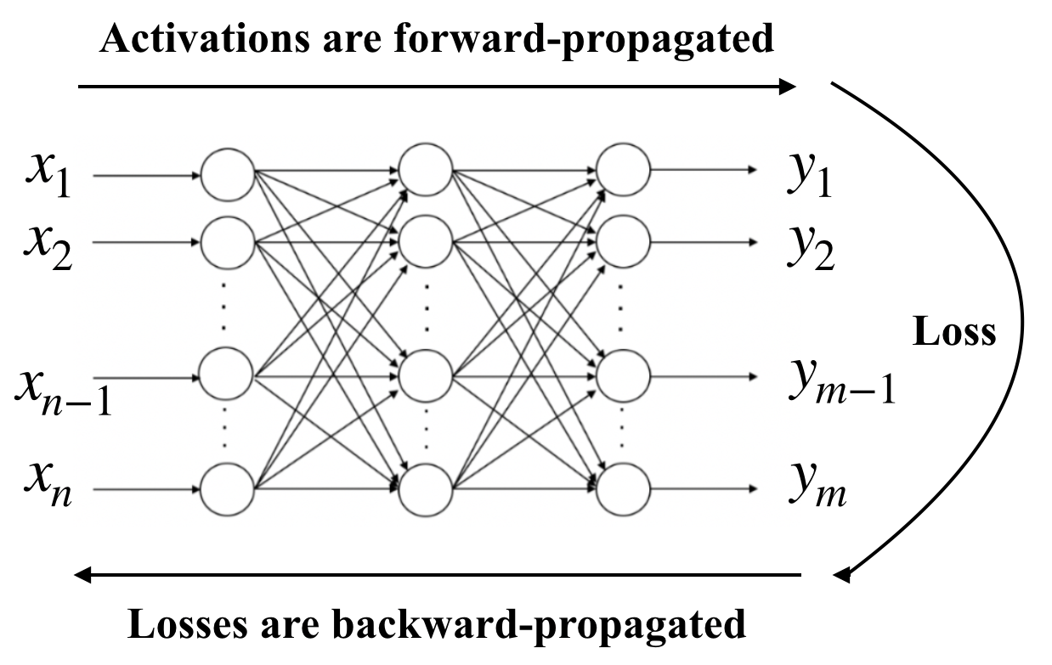

***Ist Author et al., International Research Journal of Computer Science***

Each neuron consists of an activation function that introduces non-linearity in the modelling capabilities of the

network, and its output consists of the activated-weighted sum of inputs. There exist several types of activation functions

including Sigmoid, Tanh, ReLu and Leaky-ReLu functions [12],[13].

Fig. 2 Activation Functions

The first phase of training a neural network involves forward-propagation of the training data [14], which propagate

the entire neural network and their predictions (labels) are calculated. During this phase, each neuron of each layer

applies its transformation to the information it receives from the neurons of the previous layer and sends it to the neurons

of the next layer.

Next, an error function computes the error between test data and predicted data to measure how accurate the prediction

result is compared to the correct result [15].Ideally, the error/loss must be equal to zero, that is, no divergence between

estimated and expected value. Therefore, as the model gets trained, the weights associated with each inter-neuron

interconnection are gradually adjusted until the error function reaches a minima.

After the calculation of loss, it is propagated backwards in the neural network, and this phase is called back-

propagation [16]. Starting from the output layer, the loss information propagates through all the neurons in the hidden

layers, based on which the weight associated with each inter-neuron connection is adjusted. This process is repeated,

layer by layer, until all the neurons in the network have adjusted their weights.

Fig. 3 Training a Neural Network

Optimization algorithms are used to minimise the loss by finding the minima of Objective function/Loss function

which is a mathematical function dependent on the model’s internal learnable parameters which are used in computing

the target values (y) corresponding to the set of predictors (X) used in the model. The internal parameters of a model play

a vital role in effectively and efficiently training the model and produce most accurate results.Hence, various

Optimization strategies and algorithms are used to update and compute appropriate and optimum values of such model’s

parameters.Optimization algorithms are mainly classified into two categories:

1. First Order Optimization Algorithms

2. Second Oder Optimization Algorithms

***© 2014, IRJCS All Rights Reserved Page | 3***

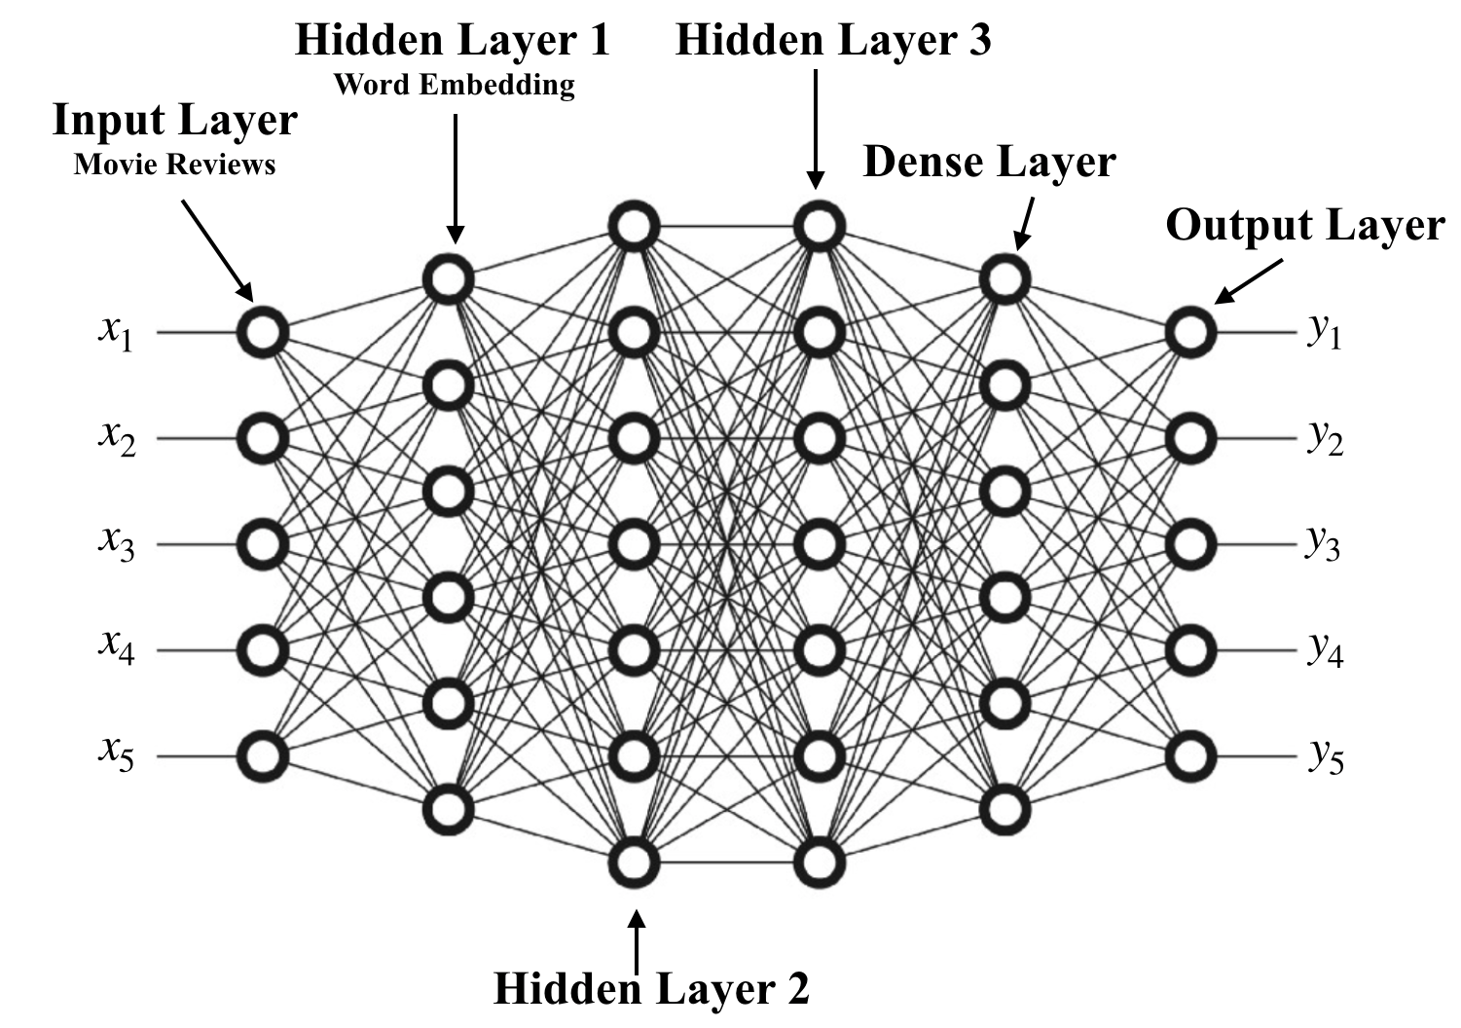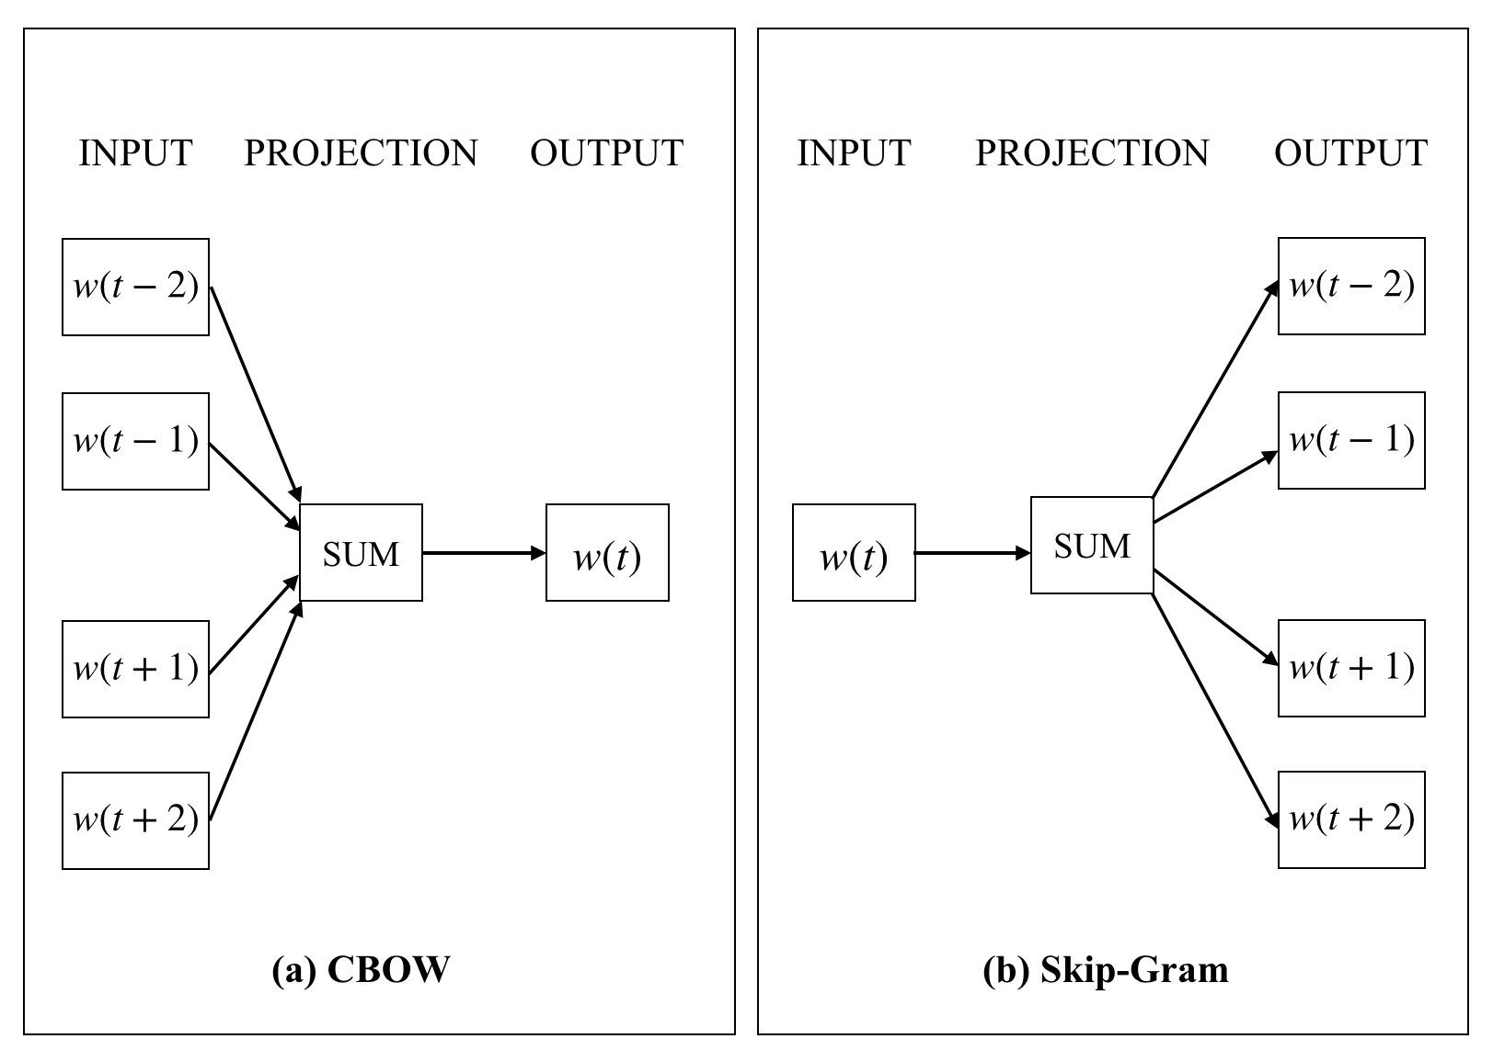

***Ist Author et al., International Research Journal of Computer Science***

*B. Word Embedding*

Word embeddings is a class of methodologies [17] which provide a dense vector representation of words and

documents, and their relative meanings.They are an improvement over the traditional sparse representations employed in

simpler bag of word models.Graphically, a dense vector represents the projection of the given word into a continuous

vector space [18]. The position of a word within the vector space, also called as embedding, is learnt from the input text

based upon the set of words surrounding the given word.

Keras, Python’s deep learning library, provides an Embedding layer implementation which can be used for neural

networks to process text data [19].

Fig. 4 Complete Neural Network

*C. Natural Language Processing*

Natural Language Processing (NLP) is a discipline that focuses on the interaction between data science and human

language, thereby giving computers the ability to parse, understand and derive insights from human languages [20]. NLP

is extensively used in various industries including healthcare, agricultural industry, fake news detection, virtual

assistants, and many more. NLP involves applying algorithms to categorise and extract the natural language rules such

that the unstructured data gets converted into a computer parsable form. The two main techniques utilised in NLP are

syntactic analysis and semantic analysis. Syntactic analysis involves techniques including lemmatization, morphological

segmentation, word segmentation, part-of-speech tagging, parsing, sentence breaking and stemming. Semantic analysis

involves techniques including named entity recognition, word sense disambiguation, natural language generation, and

many more [21].

*D. Word2Vec*

Word2Vec is a cluster of related models which can be used to generate word embeddings [22]. These models are

shallow neural networks that are trained to convert linguistic context of words into vectors. Word2vec converts a large

chunk of text into a vector space, of the order of a several hundred dimensions, with one vector assigned for each unique

word in the word space. Word2Vec offers two modes of analysis; Continuous Bag-Of-Words (CBOW) and Continuous

Skip-Gram (SG) [23]. CBOW attempts to predict the output label (target word) from its neighbouring words (context

words) , thereby achieving a better accuracy for frequent words.In contrast, CSG predicts the context words from a given

target word, working well even for infrequent words.

Fig. 5 Word2Vec Models

***© 2014, IRJCS All Rights Reserved Page | 4***

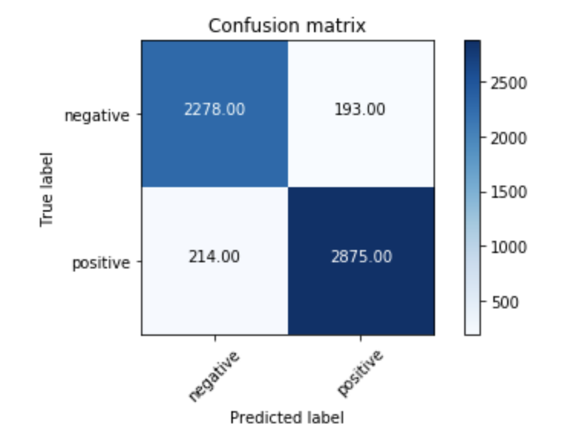

***Ist Author et al., International Research Journal of Computer Science***

Neural Probabilistic models are generally trained using the principle of Maximum Likelihood which maximizes the

probability of the next word

[24]:

*wt*

(target) given the previous words h (history) by applying softmax activation as shown

*P*(*wt*

|*h*) = *sof t m a x* (*scor e*(*wt*

, *h*))

(1)

*P*(*wt*

|*h*) =

∑ *Wor d*

exp(*scor e*(*wt*, *h*))

*ϵVoca b* exp(*scor e*(*w,*

*,*

, *h*))

(2)

Where,

*scor e*(*wt*

, *h*)

computes the compatibility of the target word

*wt*

in the context h.

This model is trained by maximising its log-likelihood on the training set.Its loss function is given as:

*JML*

= log(*P*(*wt*

|*h*)

(3)

*JML*

= *scor e*(*wt*

, *h*) − log(

∑

exp(*scor e*(*wt*

, *h*))

(4)

The Skip-Gram model defines the probability as follows:

Where,

*wi* is a one-hot encoded N-dimensional vector

*P*(*wi*

|*wt*

;*θ* ) =

exp(*θ wi*)

∑ exp(*θ wt*

)

(5)

*θ* represents N*K embedding matrix for N words in K dimensions.

V. **RESULTS**

The research is performed on 515K Hotel Reviews Data in Europe Dataset [10] consisting of 515000 customer

reviews for 1493 luxury European hotels, across 17 attributes. It is observed that Deep Learning using Artificial Neural

Networks provides excellent capability for sentiment classification on text data. The reviews are classified into the four

classes mentioned in Table 2.

**CLASS CONDITION**

Best sentiment_score >= 0.7

Good 0.7 > sentiment_score >= 0.5

Bad 0.5 > sentiment_score >= 0.3

Worst 0.3 > sentiment_score

Table 2

The Word2Vec Skip-Gram Neural Network consists of 256 neurons in the hidden layer, hence, each word has a 256-

dimensional vector representation. The Neural Network achieves a Test Accuracy of 0.9248 and a Test Loss of 0.2374.

The Confusion Matrix of the classification is shown in Fig 6.

Fig. 6 Confusion Matrix

***© 2014, IRJCS All Rights Reserved Page | 5***

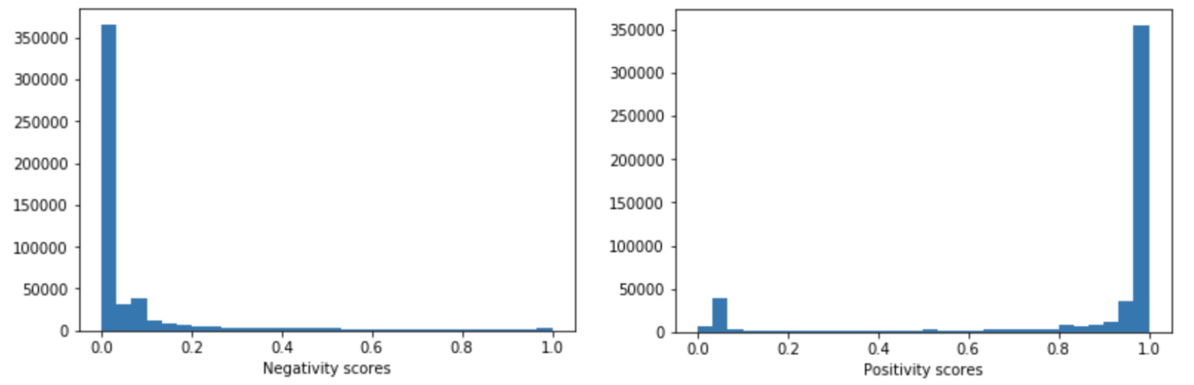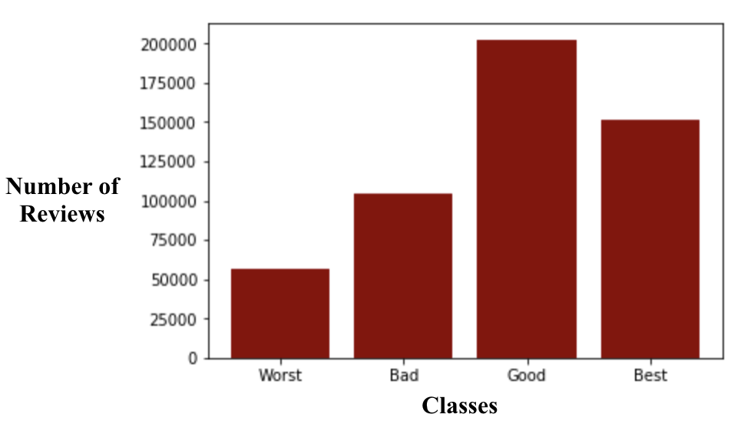

***Ist Author et al., International Research Journal of Computer Science***

The Neural Network achieves a very high classification accuracy of 0.9813 and the precision, f1-score, recall and

support values are mentioned in Table 3.

**TYPE PRECISION SPECIFICITY F1-SCORE SUPPORT**

**CLASS 0** 0.89 0.95 0.92 2428

**CLASS 1** 0.96 0.90 0.93 3122

**MICRO AVG** 0.92 0.92 0.92 5550

**MACRO AVG** 0.92 0.93 0.92 5550

**WEIGHTED AVG** 0.93 0.92 0.93 5550

Table 3

The Confusion Matrix, Positivity Scores and Negativity Scores show that only a small number of reviews are

misclassified.

Fig. 7 Positivity and Negativity Score Plots

Thus, all the reviews were accurately classified into the above mentioned four categories. The proportion of reviews

classified in each category are shown in Fig 8.

Fig. 8 Number of reviews vs Class Distribution

***© 2014, IRJCS All Rights Reserved Page | 6***

***Ist Author et al., International Research Journal of Computer Science***

VI. CONCLUSION

The research presents a deep learning methodology for sentiment analysis of customer satisfaction from hotel reviews.

The research delves into the fundamentals of Deep Learning ,Word Embedding and Natural Language Processing. The

proposed Artificial Neural Network powered by Google’s Word2Vec skip-gram algorithm accurately and successfully

classifies the customer reviews into four categories of Best, Good, Bad and Worst.

Hotel managements can utilise such algorithms to gain insights from online reviews and improve upon their

shortcomings for a better customer satisfaction and online ranking. A better ranking can boost their revenues and provide

incentives for further betterment of services. In general, service oriented companies and institutions can utilise such

technologies to keep track of their customer feedback.

REFERENCES

1. B. Huang, M. T. Kechadi, and B. Buckley, ”Customer churn prediction in telecommunications.” Expert Systems

with Applications, 39(1), 2012, pp. 1414-1425

2. Pennington, Buddy & Chapman, Suzanne & Fry, Amy & Deschenes, Amy & McDonald, Courtney. (2016).

Strategies to Improve the User Experience. Serials Review. 42. 00-00. 10.1080/00987913.2016.1140614.

3. Gullo, Francesco. (2015). From Patterns in Data to Knowledge Discovery: What Data Mining Can Do. Physics

Procedia. 62. 18–22. 10.1016/j.phpro.2015.02.005.

4. Farhadloo, Mohsen & Rolland, Erik. (2016). Fundamentals of Sentiment Analysis and Its Applications.

10.1007/978-3-319-30319-2_1.

5. Sun, Shiliang & Luo, Chen & Chen, Junyu. (2016). A Review of Natural Language Processing Techniques for

Opinion Mining Systems. Information Fusion. 36. 10.1016/j.inffus.2016.10.004.

6. B. Pang and L. Lee. 2008. Opinion mining and sentiment analysis. Foundations and Trends in Information

Retrieval, 2(1-2):1135.

7. V. Rentoumi, S. Petrakis, M. Klenner, G. A. Vouros, and V. Karkaletsis. 2010. United we stand: Improving

sentiment analysis by joining machine learning and rule based methods. In Proceedings of the Seventh conference

on International Language Resources and Evaluation (LREC’10), Valletta, Malta.

8. Alotaibi, Shaha & Alnassar, Allulo & Alshahrani, Asma & Al-Mubarak, Amany & Albugami, Sara & Almutiri,

Nada & Albugami, Aisha. (2018). Customer Satisfaction Measurement using Sentiment Analysis. International

Journal of Advanced Computer Science and Applications. 9. 10.14569/IJACSA.2018.090216.

9. Stanimira Yordanova and Dorina Kabakchieva, “Sentiment Classification of Hotel Reviews in Social Media with

Decision Tree Learning”. International Journal of Computer Applications (0975 – 8887) Volume 158 – No 5,

January 2017

10. A. Kaggle, “515K Hotel Reviews Data in Europe”. Available at: https://www.kaggle.com/jiashenliu/515k-hotel-

reviews-data-in-europe. Accessed on 28 November, 2019.

11. Vargas, Rocio & Mosavi, Amir & Ruiz, Ramon. (2017). DEEP LEARNING: A REVIEW. Advances in Intelligent

Systems and Computing. 5.

12. Nwankpa, Chigozie & Ijomah, Winifred & Gachagan, Anthony & Marshall, Stephen. (2018). Activation Functions:

Comparison of trends in Practice and Research for Deep Learning.

13. Olgac, A & Karlik, Bekir. (2011). Performance Analysis of Various Activation Functions in Generalized MLP

Architectures of Neural Networks. International Journal of Artificial Intelligence And Expert Systems. 1. 111-122.

14. Sazli, Murat. (2006). A brief review of feed-forward neural networks. Communications, Faculty Of Science,

University of Ankara. 50. 11-17. 10.1501/0003168.

15. Nie, Feiping & Zhanxuan, Hu & Li, Xuelong. (2018). An investigation for loss functions widely used in machine

learning. Communications in Information and Systems. 18. 37-52. 10.4310/CIS.2018.v18.n1.a2.

16. Hossain, Md & Rahman, Md. Mijanur & Prodhan, Dr. Uzzal & Khan, Md. (2013). Implementation Of Back-

Propagation Neural Network For Isolated Bangla Speech Recognition. International Journal of Information

Sciences and Techniques. 3. 10.5121/ijist.2013.3401.

17. Li, Yang & Yang, Tao. (2017). Word Embedding for Understanding Natural Language: A Survey.

10.1007/978-3-319-53817-4.

18. Teofili, Tommaso. (2017). par2hier: towards vector representations for hierarchical content. Procedia Computer

Science. 108. 10.1016/j.procs.2017.05.077.

19. Zebin, Tahmina. (2017). Training Deep Neural Networks in Python Keras Framework(Tensorflow Backend) with

Inertial Sensor Data for Human Activity Classification.

20. Verspoor, Karin & Cohen, Kevin. (2013). Natural Language Processing. 10.1007/978-1-4419-9863-7_158.

21. Dr. Michael J. Garbade, “A Simple Introduction to Natural Language Processing”. Available at: https://

becominghuman.ai/a-simple-introduction-to-natural-language-processing-ea66a1747b32. Accessed on: 20

December, 2019.

22. Dhingra, Atul. (2017). How Does Word2Vec Work ?. 10.13140/RG.2.2.18448.92163.

23. Derek Chia, “An implementation guide to Word2Vec using NumPy and Google Sheets”. Available at: https://

towardsdatascience.com/an-implementation-guide-to-word2vec-using-numpy-and-google-sheets-13445eebd281.

Accessed on: 20 December, 2019.

24. Chen, Ding-Geng & Lio, Yuhlong. (2009). A Note on the Maximum Likelihood Estimation for the Generalized

Gamma Distribution Parameters under Progressive Type-II Censoring. International Journal of Intelligent

Technology and Applied Statistics. 2. 57-64.

***© 2014, IRJCS All Rights Reserved Page | 7***